**Report based on my project Student Attendance Management System:**

**Abstract:**

The **Student Attendance Management System (SAMS)** is a digital process of tracking student attendance in educational institutions. This system replaces traditional methods with a secure, efficient, and user-friendly platform. It consists of three main modules: **Admin**, **Teacher**, and **Student**, each with specific functionalities. The system ensures accurate record-keeping, reduces administrative workload, and provides real-time attendance data . This report covers the system's design, implementation, ER diagram, activity flow, advantages, and future scope.

**Table of Contents:**

1. **Introduction**
2. **Objectives**
3. **System Requirements**
   * Functional Requirements
   * Non-Functional Requirements
4. **System Design**
   * ER Diagram
   * Activity Diagram
5. **Modules Description**
   * Admin Module
   * Teacher Module
   * Student Module
6. **Implementation**
   * Technologies Used
   * Database Structure
7. **Advantages of the System**
8. **Challenges and Solutions**
9. **Future Enhancements**
10. **Conclusion**

**1. Introduction:**

Educational institutions require an efficient attendance tracking system to monitor student participation and generate reports. Traditional paper-based methods are error-prone and time-consuming. The **Student Attendance Management System (SAMS)** provides a digital alternative, integrating features such as:

* Automated attendance marking
* Role-based access control
* Make repore on every students

This system enhances transparency, reduces manual effort and time wasting , and improves accuracy.

**2. Objectives:**

* Automate attendance recording and management.
* Generate attendance reports for analysis.
* Minimize human errors in attendance tracking.
* Ensure secure access through role-based authentication.

**3. System Requirements:**

**Functional Requirements**

* **Admin:**
  + Manage student and teacher records.
  + Create and assign courses/classes.
  + Generate attendance reports.
* **Teacher:**
  + Mark student attendance.
  + View attendance records.
  + Export attendance data.
* **Student:**
  + View personal attendance percentage.
  + Check attendance history.
  + Can request for change if needed.

**Non-Functional Requirements:**

* Secure login (authentication ).
* Responsive and user-friendly interface.
* Scalable database for large datasets.
* Fast processing and report generation.

**4. System Design:**

**ER Diagram**

The **Entity-Relationship (ER) Diagram** defines the database structure:

* **Entities:** Admin, Teacher, Student, Class, Attendance.
* **Relationships:**
  + Admin **manages** Teachers and Students.
  + Teacher **teaches** Class.
  + Student **belongs to** Class.
  + Attendance **is marked in** Class.

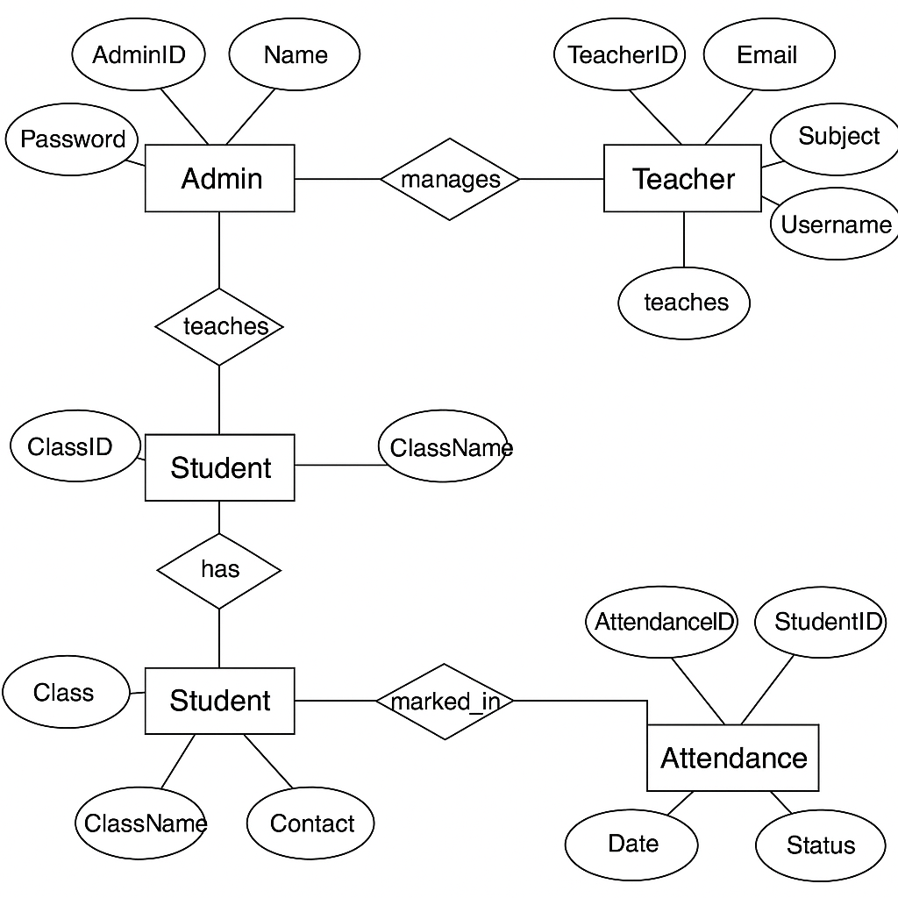

**Activity Diagram:**

The **Activity Diagram** illustrates the workflow:

1. **Login** → Role selection (Admin/Teacher/Student).
2. **Admin Module:** Manages users and classes.
3. **Teacher Module:** Marks attendance and views records.

**Student Module:** Checks attendance percentage and can apply to changes if needed.

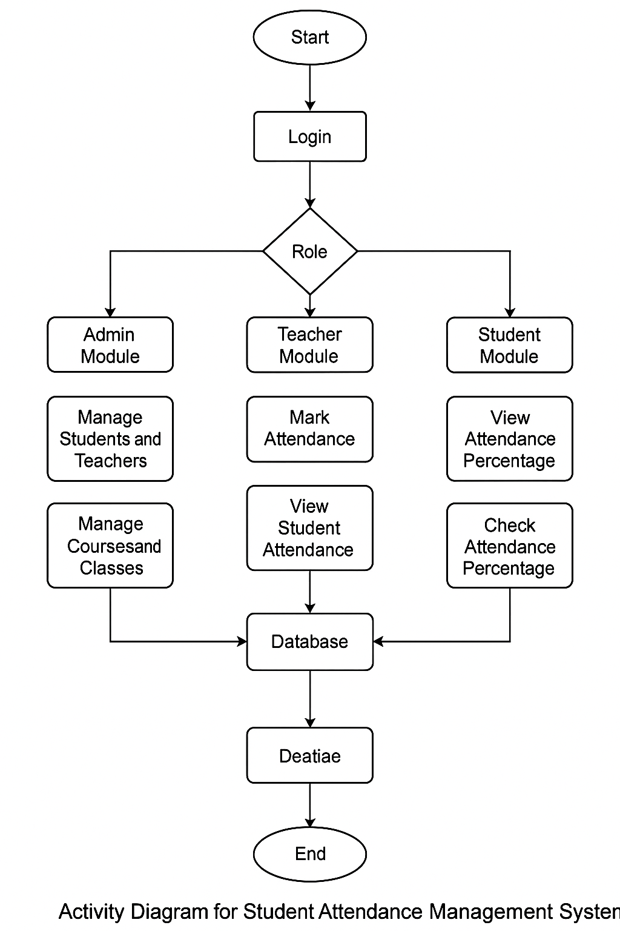

**5. Modules Description:**

**Admin Module**

* **User Management:** Add/Edit/Delete students and teachers.
* **Course & Class Management:** Assign classes to teachers.
* **Reports:** Generate attendance summaries.

**Teacher Module**

* **Mark Attendance:** Daily attendance entry.
* **View Records:** Filter by date/class.

**Student Module**

* **View Attendance:** Check daily/weekly/monthly records.
* **Can apply for changes if needed.**

**6. Implementation:**

**Technologies Used**

* **Frontend:** Python (Tkinter GUI)
* **Backend:** Python
* **Database:** MySQL and Sqlit (Relational Database)
* **Authentication:** Simple login system using MySQL and sqlit.

**Database Structure-**

* **Tables:**
  + Admin (AdminID, Name, Email, Password)
  + Teacher (TeacherID, Name, Subject, ClassID)
  + Student (StudentID, Name, ClassID, Contact)
  + Attendance (AttendanceID, StudentID, Date, Status)

**7. Advantages of the System-**

**Efficiency:** Reduces manual work.  
 **Accuracy:** Minimizes errors in attendance tracking.  
 **Transparency:** Real-time access for students and teachers.  
 **Scalability:** Supports large institutions.  
 **Security:** Role-based access control.

**8. Challenges and Solutions**

| **Challenge** | **Solution** |
| --- | --- |
| 1)Data security risks | Implement of MySql.. |
| 2)Bulk attendance entry | Provide Excel upload option. |
| 3)Network dependency | Offline mode with sync later. |

**9. Future Enhancements:**

* **Mobile App:** For attendance marking on the go.
* **Biometric Integration:** Fingerprint/Face recognition.
* **AI Analytics:** Predict student absenteeism trends.
* **Parent Portal:** Notify parents of low attendance.

**10. Conclusion:**

The **Student Attendance Management System (SAMS)** is a robust, scalable, and efficient solution for educational institutions. By automating attendance tracking, it saves time, improves accuracy, and enhances transparency. Future enhancements like biometric integration and AI analytics will further optimize the system.

This system is a step towards **digital transformation in education**, ensuring better accountability and streamlined operations.